The putative carcinogenic effect of folic acid overdose in higher age
Rácz Oliver, Sedláková Eva, Lovásová Eva, Nováková Jaroslava, Ništiar František
Šafárik University, Medical School, Košice, Slovakia
Jan Grodek National Vocational High School, Institute of Nursing
Sanok, Poland

1. Introduction

Folates are essential micronutrients from the group of B vitamins. (Fig. 1) Man and animals obtain folates from food or from gut microorganisms. The synthetic precursor of folates available as an over the counter pill or as an additive to different foods is the folic acid (Fig. 1). The natural compounds are tetrahydrofolates, which contain also methyl or formyl groups (5-methyltetrahydrofolate, 5,10-methylenetetrahydrofolate and 10 formyltetrahydrofolate). The situation is even more complicated because instead of one glutamate moiety depicted in Fig. 1 the natural compounds occur mostly as polyglutamates (Scott, 2009).
The most important metabolic pathway in which folates act as donors of one-carbon groups is the synthesis of purine and pyrimidine bases – building blocks of nucleic acids. In folate deficiency there is a decrease of thymidine synthesis catalyzed by thymidylate synthase. The consequence is incorporation of uracyl base into DNA instead of thymidine. DNA synthesized in folate deficiency is unstable and chromosome breaks are also present in this condition. Folates on the other side provide methyl groups also for DNA methylation, a way of gene expression blockade. Vitamin B₁₂ is a coenzyme of the enzymes catalyzing these reactions.
The metabolism of folic acid is also associated to with the metabolism of methionine and homocysteine. In the case of folic acid deficiency there is an increase in blood homocysteine concentration considered as an independent risk factor of coronary artery disease. This condition is associated also with the deficiency of the key enzyme involved in homocysteine remethylation to methionine – the 5,10-methylene tetrahydrofolate reductase (MTHFR). Slightly decreased acitivity of MTFHR is a common trait due to C677T polymorphism in its gene leading to an exchange of valine to alanine in the protein (Kang et al, 1988, Frosst et al, 1995).
Aminopterine, a structural analogue of folic acid interferes with its metabolism and blocks the synthesis of nucleic acids. In past it was used in the treatment of leukemia. Sulphonamides block the synthesis of folic acid in bacteria, which is the basis of their antibacterial effect. Another important antagonists of folates are anticonvulsive drugs as carbamasepine, phenobarbital and valproate.

Fig. 1.
The structure of folic acid

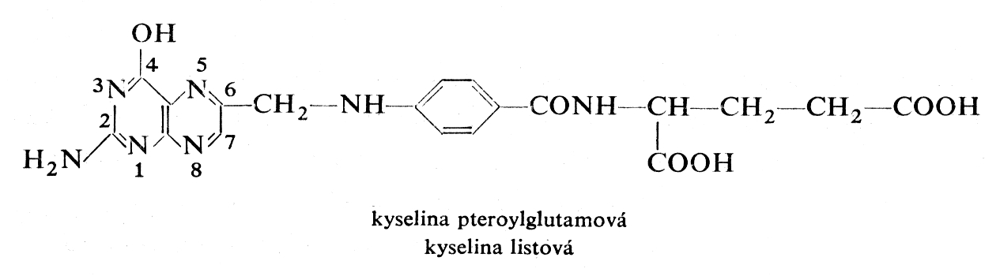The –OH groups are attached to the C7, N8 (dihydrofolate) and C6, N5 atoms of the pteridine part of the molecule, the methyl group to the N5 atom.

2. The consequences of folic acid and vitamin B₁₂ deficiency and their prevention

Severe folic acid and vitamin B₁₂ deficiency in the past caused pernicious anaemia. This disease in its fully developed form was however not only anaemia but also involved the damage of many tissues and organs dependent on intense nucleic acid synthesis – mucous membranes, heart muscle and also peripheral nerves. Deficiency of these micronutrients was in the past common in patients with chronic kidney failure on dialysis and supplementaion of folic acid (but not of B₁₂) is therefore recommended also during erythropetin treatment of dialyzed patients (Mydlík et al 1991, 1995).
Marginal deficiency of folic acid is associated with increased occurrence of congenital defects (Rush, 1992, Czeizel, 1994) and some malignancies (Pauwels, 2008). The possibility of association of folic acid deficiency with other diseases is not unambiguously proved (Tab. 1).
The recommended daily dose of folic acid is age and sex dependent (Tab. 2). From data of food consumption it is clear that the intake of folic acid from natural sources in most countries across Europe and North America is sufficient to prevent anaemia but is not sufficient against development of neural tube defects (NTDs) in offspring of women in reproductive age. Very low intake was demonstrated in Hungary (Zajkas et al., 2007) and Ireland (ESCO, 2008).
A short list of folic acid content in different foods is in table 3. Interestingly high amount of folic acid is present in some foods (strawberries) in which according to classical knowledge on micronutrients it is not expected and low in some others in which according to general belief the amount of vitamin B members should be high (whole grain bakery products, etc.). A confounding factor in folic acid content in food is that in most vegetables folates accour in the form of low bioavailability polyglutamates. Therefore the data on food consumption do not provide reliable information on true folate supply.
Some data on blood folate concentration measured by a reliable immunochemical method show that the lowest levels are in European population (probably due to low consumption of vegetables) and the highest in USA where food fortification with folic acid was introduced in 1998 (Tabs. 4 and 5). In Poland Chabasinska et al (2007) found higher level of folate (and lower level of B₁₂) in vegetarians as compared to omnivores but the difference was small (17,3 vs 15,2 nmol/l). Overt deficiency was present only in the nonvegetarian group.

Tab. 1
Established and possible beneficial effects of folic acid supplementation (according to Murray, 1996)
Established | Megaloblastic anaemia caused by folic acid deficiency  Neural tube defects  Breast carcinoma
Probable | Other congenital defects and chromosome aberrations (orofacial and abdominal wall defects, Down syndrome)  Other malignant tumors  Atherosclerosis (through homocystein decrease?)
Possible, not proved | Lens cataract  Cerebrovascular insufficiency  Obstipation, diarrhoe  m. Crohn, coeliac disease  m. Parkinson, epilepsy  Hepatitis  Infertility  Osteoporosis  Gout  Acne  Cognitive functions in higher age

Tab. 2
Recommended doses of folic acid intake for different groups of population
Group | Recommended doses  Micrograms/day
Children, < 12 months | 50 – 80
Children, 1 – 3 years  Children, 4 – 6 years  Children, 7 – 10 years | 70 – 200  100 - 300  150 – 300
Adolescents | 200 – 400
Adult women  Adult men | 200 – 400  200 – 300
Women, gravidity  Women, lactation | 300 – 600  260 – 600
High age | 200
In some European countries there are other recommended doses – the highest in Switzerland and the lowest in Great Britain
In high risk gravidities (NTDs in personal history, diabetes, epilepsy of the mother) the recommended doses in some countries are as high as 4000 micrograms daily
Table 3
Foods with low and high amount of folic acid

LOW (< 400μg /100g )
Potatoes
Bread, bakery*
Rice**
Milk, yoghurt, cheese***
Oat flakes
Beer, apple/orange juice
Banana, orange, kiwi
Carrot
Tomato
Cabbage
Onion
Cucumber
Fish

HIGH (> 400μg /100g )
Wheat sprouts 900 μg /100g
Psenicne bran 470
Eggs, boiled 420
Strawberries 650$
Chiccory 420
Beans, different types and different
food processing 410 - 1500
Spinach, boiled 830
Broccoli, boiled 650
Cabbage$$ 500
Cauliflower 550
Asparagus 560
Leek 420
Poultry 2 mg/100g
Liver$$$ up to 14 mg/100g

*With the exception of white bakery products (cca 390 μg/100 g)
** More in white than in brown rice (210 vs 50 μg/100g). This is not a negligible amount considering the dietary habits in China and other Asian countries.
*** With the exception of “brie” (cca 380 μg/100 g)
$ No available data on other “berries” and currants popular especially in Eastern and Central Europe
$$ Not in sauercraut and in red cabbage
$$$ Maximum in poultry liver. On the other side high consumption of liver is not recommended for the possible accumulation on toxic substances in it.

Tab. 4
Normal values of folates in blood
Normal values 7,0 – 39,7 nmol/l
Marginal deficiency 5,0 – 6,8 nmol/l
Deficiency <5,0 nmol/l
According to Kratz and Lewandrowski, 1998

Tab. 5
Folate concentration in selected healthy populations measured by Folate II Elecsys assay (Roche)
Region | Number | Folate, nmol/l  median | 2,5 percentil | 97,5 percentil
Australia 1 | 194 | 25,2 | 13,0 | > 45,4
Australia 2 | 182 | 19,5 | 10,4 | > 45,4
Europe | 292 | 17,5 | 8,6 | 36,3
USA | 167 | 32,7 | 19,1 | 79,9

3. The pathogenesis of neural tube defects

The neural tube differentiation begins very early, already in the 3rd – 4th week of gestation. This period is a very sensitive one and different disruptive factors can lead to neural tube defects or even to anencephaly (Fig. 2). The first reports on beneficial effects of folic acid supplementation on NTD prevention were published in the second half of the last century (Hibbard and Smithells, 1965). Based on experimental studies and double blind clinical trials it is now clear that appropriate supplementation before conception and in the first weeks of gestation can prevent as much as 70 % of NTDs (Czeizel and Dudas, 1992). The others are probably caused by gene mutations. Some of the NTDs are associated with chromosome aberrations or monogenic syndromes (Harris and Juriloff, 2007, Behunova and Podracka, 2008).
An important issue is the association between slight decrease of MTFHR activity due to common C677T gene polymorphism and folate deficiency (Behunova et al, 2009, 2010). This association can explain the question why folate deficiency affects mostly the development of neural tube. From practical point of view this emphasizes the need of routine genetic testing of MTFHR polymorphism in young women because carriers of the “T” allele are at higher risk of NTD in the case of mild folate deficiency than those with the “C” allele. Other factors affecting the development of NTDs are summarized in Table 6.
Anencephalus is of course not compatible with life but children with meningomyelocele survive. They need intense medical and paramedical care because urine incontinence, lower extremities paresis, disturbances of skin sensitivity is common among them. One third of the children with NTDs also reveal some degree of mental retardation (Horn, 2005).

Table 6
Condition associated with NTDs and the possibility of their modification with increased folic acid supplementation

Conditon | Possibility of modification  By folic acid supplementation
Gene mutations affecting factors of neural tube development but not involved in folate metabolism | NO
Gene polymorphisms affecting enzymes of folate metabolism (MTFHR C677T) | YES
Chromosome aberrations (Down syndrome) | PROBABLY YES IN SOME CASES
NTD is previous gravidity | PROBABLY YES IN SOME CASES
Drugs acting as folate antagonists | YES
Obesity, insulin resistance, diabetes mellitus | ?
Hypertermia | YES
Fig 2.
The different forms of neural tube defects

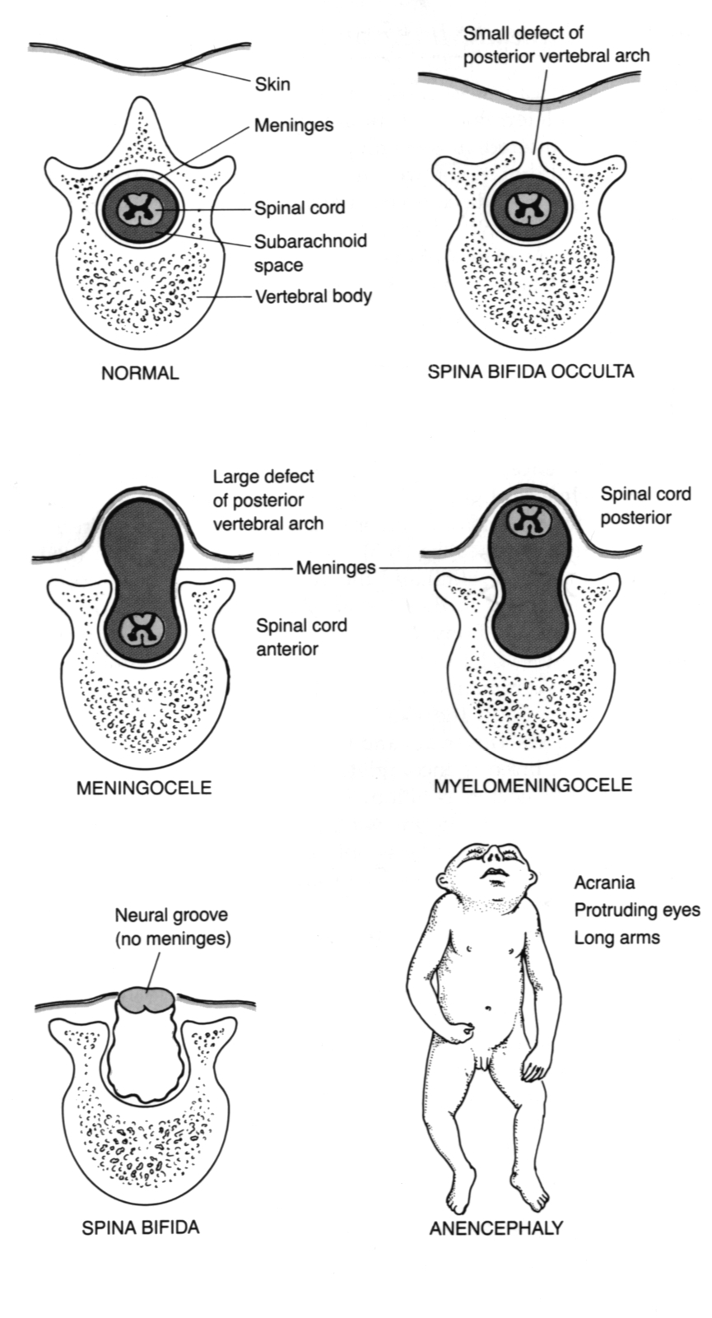
Folic acid supplementation and food fortification is recommended and introduced in many countries of the world from the eighties of last century. In European Union the fortification is regulated through directive No. 1925/2006. The list of fortified foods is long; a survey about them is in Table 7. Mandatory fortification of flour in countries of European Union is not established but is frequently used in many poor countries of Africa, Middle East and South America (usually together with other micronutrients). In the last years of the 20th century mandatory fortification of flour was introduced in USA and Canada.
The usual way of increased intake before and during pregnancy is the application of multivitamin formulas from the end of anticonception until the 12th week of gestation. According to German health care professionals the supplementation should be introduced 2 months before the planned conception and it should be continued until the 8th months of pregnancy. This simple way of increased intake of folic acid fails to work in non-planned pregnancies typical for women with low education and unhealthy life style. These women at the same time are at otherwise elevated risk of health problems during pregnancy. The social inaeqality in this form of folic acid supplementation as a preventive measure against NTDs is the main argument for mandatory fortification.
The amount of added folic acid is variable – from 3 up to 600 micrograms/100 grams of product. The proportion of fortified products on the market is in most countries unknown or low. Two exceptions in Germany and Great Britain are the cereals – their market share is between 45 and 75 %. In Germany there is a discussion about the limit of added folic acid to 100 micrograms/dose of foodstuff and about a ban of beverage and salt fortification.

Tab. 7
The list of folic acid fortified products in different countries of European Union
Milk and dairy products, yogurts
Flour, bread, cereals
Spreads
Soya products
Nonalcoholic beverages (fruit juices)
Kitchen salt

4. Congenital malformations of the nervous system – the current situation in the world, in Europe and in Slovakia

The EUROCAT database of congenital anomalies founded in 1979 acquires data from about 1,5 million deliveries each year (about one third of all deliveries in Europe). Despite some differences in data acquisition and quality EUROCAT is a powerful source of information about the occurrence of NTDs. According to this database the incidence of NTDs is in the range of 9 – 12 cases in 10000 deliveries. The incidence decreased continuously till 1990 and was stagnating from this year.
In Slovakia there were 6 cases of spina bifida (diagnosis Q05) in 2006. Together with diagnoses Q00 and Q01 (anencephalus and encephalocele) the total number was 15. Similar occurrence was also in the years 2001 - 2005. Calculated to the number of deliveries the occurrence is much lower (0,72 spina bifida in 10000 births and 2,2 cases of Q00 and Q01/10000 pregnancies) compared with the data of EUROCAT. The cause of discrepancy between the EUROCAT and Slovak data is not known but is probably not a consequence of insufficient data acquisition (Behunova and Podracka, 2008). On the other side the Slovak data are in agreement with the data from Canada.

5. Latent forms of NTDs and other problems associated with evaluation of epidemiological results.

An unresolved issue of NTD epidemiology is that not every case is recognized immediately after birth. The databases contain only a part of them - the spina bifida cystica (aperta) with meningocele. The number of spina bifida occulta (without the involvement of spinal cord injury) is probably much higher. According to Detrait et al. (2005) the ratio of open and latent forms is 15/85.

6. The putative association between high intake of folic acid and colon cancer.

In 2007 Mason et al. published a paper on possible association between increased intake of folic acid and the incidence of colorectal cancer in Canada where mandatory fortification was introduced in 1998. Between 1993 and 2002 the incidence of NTDs in Canada decreased by 46 % (from 1,58 down to 0,86/10000 births; De Wals et al., 2007) On the other side after 1998 in Canada and USA an increased incidence of colorectal cancer was recorded. The increase occurred after a long lasting decrease of the incidence of this particular malignity. The increase was statistically significant but not very marked (4 – 6 extra cases in 100 000 inhabitants in a year).
The Mason hypothesis has a rationale scientific background. Folic acid is a growth factor and is therefore essential also for the cells, which lost the control of cell division. Optimal intake can be a preventive factor against malignant growth (e.g. breast cancer – Mason and Levesque, 1996, Ericson et al., 2007). On the other side high intake in conditions when uncontrolled cell division is already established can accelerate tumor development. Papers on accelerated tumor development connected with high folate concentration were published already in the past but these were based on experiments and in vitro observations and were carried out with nonphysiological high concentrations of folate and/or on animals or tissues with established lesions (for review of the older literature see Ulrich, 2007).

7. Colorectal cancer in Europe and in Slovakia

Colorectal cancer is the second most frequent malignancy both in men (after prostate cancer) and in women (after breast cancer). The incidence begins to increase after 45 years of age and culminates around 65. The results of treatment of colon cancer are fairly good if the condition is diagnosed early but the overall number of deaths on colon cancer in European Union is as high as 140 000 each year.
In Slovakia there was a constant increase of colon cancer incidence between 1978 and 2003 (Ondrušová et al., 2008, Table 8). In Germany the incidence was somewhat lower (about 8 cases/10 000 yearly; Caca, 2007) but the trend was similar.

Tab. 8
The incidence of colon cancer in Slovakia
Year | Incidence/100 000 | Increase as compared with 1978, %
1978 | 9,34
1983 | 12,23 | 30,9
1988 | 15,53 | 66,3
1993 | 16,70 | 78,8
1998 | 20,35 | 117,9
2003 | 21,88 | 134,3
According to Ondrušová et al., 2008

8. Highlights of European Food and Safety Authority Workshop (Uppsala, January 2009) on possible effects of high folic acide intake.

- The results of experimental research on carcinogenic effect of high doses of folic acid are unequivocal. High doses of folic acid boost the growth of preequisting malignant or precancerous laesions. On the other side the conditions of these experiments and the doses applied were far from doses present in human diet and from the doses applied in judicious supplementation.
- There is some circumstantial epidemiological evidence about the possible association between high folic acide intake and colorectal carcinoma. On the other side the interpretation of the results is ambiguous. The rise of colorectal cancer occurred almost simultaneously with the introduction of mandatory flour fortification and therefore a causal association between these two events is at least suspicious. Epidemiological data on association between folic acid intake and malignancies are of uncertain value. Among them there are studies claiming beneficial, no or harming effect of folic acid on tumor development.

No consensus was reached in the question of mandatory fortification of flour with folic acid. The only proponents of this proposal were some experts from Great Britain. The rationale behind their opinion is that the multivitamin formulas and the fortified foods are not available for them who need it above all – people with low socioeconomic status and education. On the other side bread made from fortified flour is cheap. However the media fuzz about the possible carcinogenic effect of high dose folic acid made their opinion untenable also at home.

Paradoxically, low-level overall fortification of one nutrient is less dangerous as compared with the present situation. The amount of folic acid from freely available fortified foods and formulas in some groups of population can surpass the upper safe limit (1 mg/day) of folic acid intake. An already dangerous intake can happen typically in middle aged and old people who are conscientious about their life style and health and therefore consume a lot of „healthy food“.

Even more critical is the possible danger in patients with already established malignant conditions. There patients are often anemic but the prescription of high doses of folic acid without any analysis of the etiology of anemia is a categorical hazard and is strongly contraindicated.

References

Behunova J, Podracka L: Rázštepy nervovej trubice – súčasné pohľady na etiopatogenézu a možnosti prevencie kyselinou listovou. Česko-slovenská pediatrie 63, 2008, 38 – 46
Behunova J, Zavadilíková E, Šamudovská K, Hedvig J, Capová J, Sýkora P, Kovács L,
Potočeková D, Podracká Ľ: Neural tube defects – the incidence of MTFHR polymorphisms in Slovak population. Acta Paediatrica 97, 2008, Suppl. 459, 200
Behunová J, Klimčáková L, Zavadilíková E, Potočeková, Sýkora P, Podracká Ľ:
Methylenetetrahydrofolate reductase gene polymorphisms and neural tube defects epidemiology in Slovak population. Birth Defects Research Part A: Clinical and Molecular Teratology, 88, 2010, in press
Caca C: Colorectales Carzinom: Oncologie. Coloproctology 30, 2008, 179 – 187
Chabasińska M, Przysławski J, Lisowska A, Schlegel-Zawadska M, Grzymysławski M, Walkowiak J: Surowicze stężenia witaminy B12 I kwasu foliowego u wegetarian. Przegląd Med Uniw Rzeszowskiego 4, 2007, 360 - 362
Cratz AND, Lewandrowski CB: MGH case records: Normal reference laboratory values. New Engl J Med 339, 1998, 1063 - 1072
Czeizel EA: The primary prevention of birth defects: Multivitamins or folic acid? Int J Med Sci 1, 2004, 50 – 61
Czeizel EA, Dudas I: Prevention of the first occurence of neural-tube defects by periconceptional vitamin supplementation. N Engl J Med 327, 1992, 1832 – 1835
De Wals P et al: Reduction in neural-tube defects after folic acid fortification in Canada. N Engl J Med 2007, 357.135 – 142
Detrait EG, George TM, Etchevers HC et al: Human neural tube defects: Developmental biology, epidemiology and genetics. Neurotoxicol Teratol 27, 2005, 515 – 524
Ericson U et al: High folatee intace is associated with lower breast cancer incidence in postmenopausal women in the Malmö Diet and Cancer cohort. Am J Clin Nutr 2007, 86, 434 – 443
ESCO Working Group: Analysis of risks and benefits of fortification of food with folic acid. EFSA Interim report, October 2008
European Concerted Action on Congenital Anomalies and Twins (EUROCAT): http:// www.eurocat.ulster.ac.uc
Frosst P, Blom HJ, Milos R et al: A candidate genetic risk factor vascular disease: a common mutation in methylentetrahydrofolate reductase. Nat. Genet. 10, 1995, 111 – 113
Harris MJ, Juriloff DM: Mouse mutants with neural tube closure defects and their role in understanding human neural tube defects. Birth defects Res 79, 2007, 187 – 210
Hibbard ED, Smithells RW: Folic acid metabolism and human embryopathy. Lancet i, 1965, 1254
Horn F: Spina bifida – kaudálne defekty neurálnej rúry. Prešov, vyd. M. Vaška, 2005, 96 s.
Kang SS, Wong PWK, Zhou J et al: Thermolabile methylentetrahydrofolate reductase in patients with coronary artery disease. Metabolism 37, 1988, 611 – 613
Mason JB: Folate and colonic carcinogenesis: Searching for and mechanistic understanding. J Nutr. Biochem 5, 1994, 170 – 175
Mason JB et al: AND temporal association between folic acid fortification and an increase in colorectal cancer rates may be illuminating important biological principles: a hypothesis. Cancer Epidemiol Biomarkers Prev 16, 2007,1325 – 1329
Mason JB, Levesque T: Folate: Effects on carcinogenesis and the potential for cancer chemoprevention 1996 xxx
Mydlík M, Macháňová I, Derzsiová K, Pribylincová V, Řezníček J: Vitamín B12 a kyselina listová pri chronickom zlyhaní obličiek a po transplantácii obličky. Čas. Lék. Čes. 130, 1991, 84 – 87
Mydlík M, Derzsiová K, Macháňová Y, Zimáček J: The effect of erythropoetin on vitamin B12 and on folic acid in haemodialysis patients. Aktual. Nefrol. 2, 1995, 24 – 26
Murray MT: Encyclopedia of nutritional supplements. Prima Publishing, Rocklin, USA, 1996, 119 – 126
Ondrušova M et al: Komplexná analýza výskytu a úmrtnosti na zhubné nádory v Slovenskej republike. Bratislava, Národný onkologický register SR. 30.5.2008 http://www.nor-sc.org, ISBN 978-80-89292-05-9
Pauwels ECJ: The folate puzzle: The Janus face of folate in cancer medicine. Drugs Future 33, 2008, 347 – 353
Rush D.: Folate supplements prevent recurrence of neural tube defects, FDA Dietary Supplement Task Force. Nutrition Reviews 1992, 50, 22 – 28
Scott JM: Folate metabolism: Overview of risks and benefits of folic acid fortification. EFSA/SLU scientific meeting, Uppsala, 21-22 January 2009
Ulrich CM: Folate and cancer prevention: a closer look at a complex picture. Am J Clin Nutr 2007, 86, 271 – 273
Vrodené chyby v SR 2006. Národné centrum zdravotnickych informácii. Bratislava 2007
Zajkas G, Biró L, Greiner E, et al: Dietary survey in Hungary, 2003 – 2004. Micronutrients, vitamins. Orv. Hetilap 148, 2007, 1593 – 1600

