PROTOCOL FROM PRACTICAL LESSON IN PATHOPHYSIOLOGY No.
Name: |  | Group:
 |  | Year: 2022/2023
Topic: Acid-base disorders – Case studies
Aim:

Case study 1:
pH =

pCO₂ =

HCO₃¯ =

Other:

Case study 2:
pH =

pCO₂ =

HCO₃¯ =

Other:

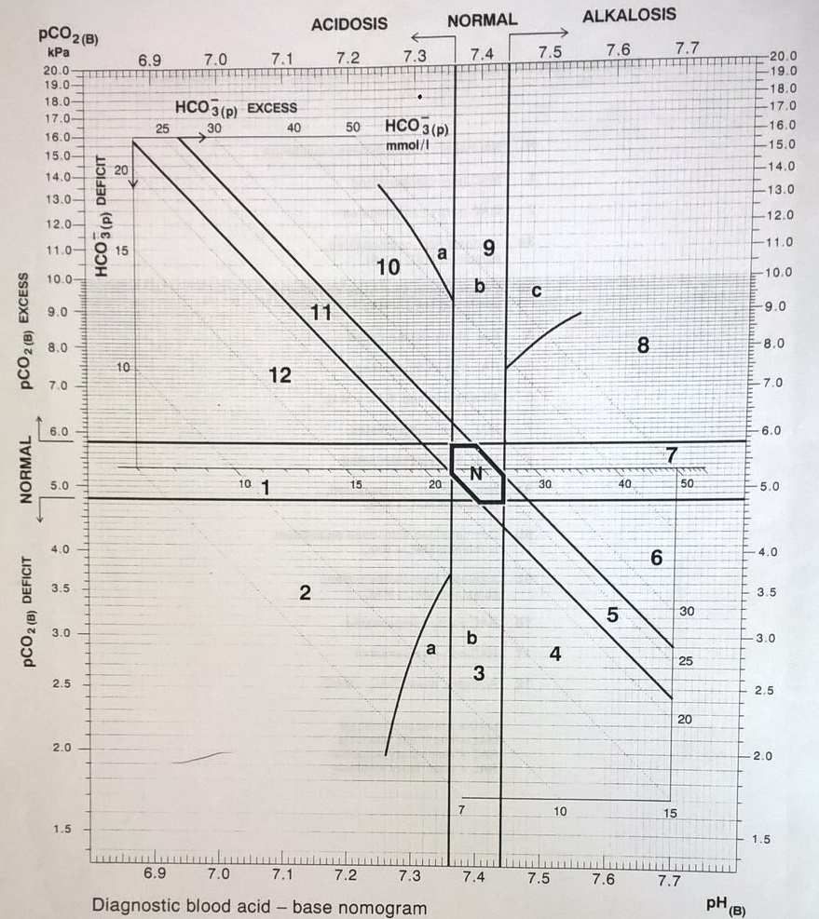

Draw the values of the acid-base parameters (pH, pCO₂ HCO₃ ̄) from case studies 1 and 2 in the diagram.
Conclusions:

Signature: | Date:

